Fire Alarm Circuit is a simple circuit that detects the fire and activates the Siren Sound or Buzzer. Fire Alarm Circuits are very important devices to detect fire in the right time and prevent any damage to people or property.

[adsense1]

Fire Alarm Circuits and Smoke Sensors are a part of the security systems which help in detecting or preventing damage. Installing Fire Alarm Systems and Smoke Sensors in commercial buildings like offices, movie theatres, shopping malls and other public places is compulsory.

There are many expensive and sophisticated Fire Alarm Circuit in the form of stand-alone devices, but we have designed five very simple Fire Alarm Circuits using common components like Thermistor, LM358, Germanium Diode, LM341 and NE555.

We will see all these circuit, their circuit diagrams, components required for each circuit and the working of the individual circuit in the following sections.

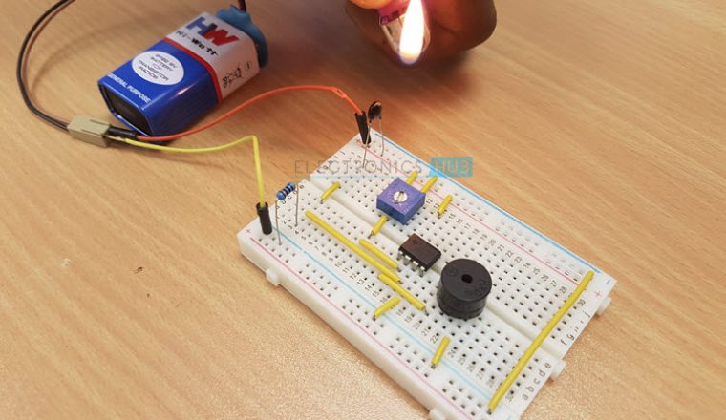

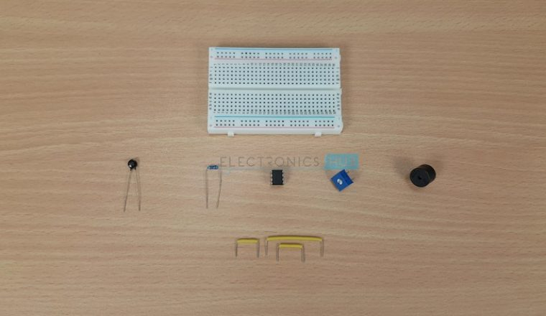

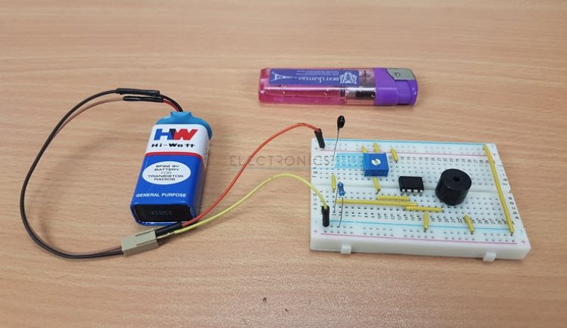

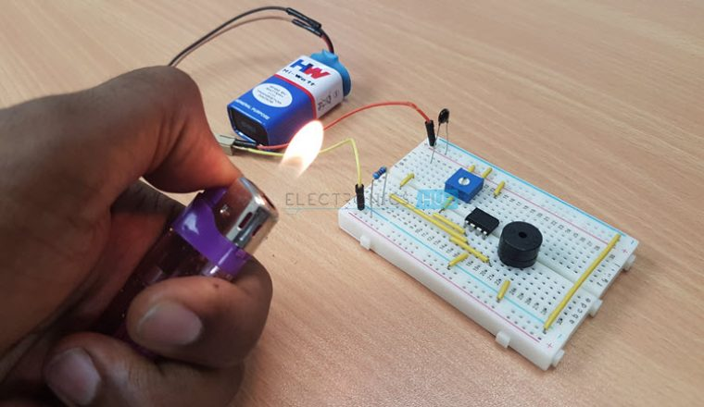





[adsense2]

Outline

[](https://www.electronicshub.org/simple-fire-alarm-circuit/)

* [Circuit 1 Simple Fire Alarm Circuit](https://www.electronicshub.org/simple-fire-alarm-circuit/#Circuit_1_Simple_Fire_Alarm_Circuit)
  + [Circuit Diagram](https://www.electronicshub.org/simple-fire-alarm-circuit/#Circuit_Diagram)
  + [Components Required](https://www.electronicshub.org/simple-fire-alarm-circuit/#Components_Required)
  + [Component Description](https://www.electronicshub.org/simple-fire-alarm-circuit/#Component_Description)
  + [Circuit Design](https://www.electronicshub.org/simple-fire-alarm-circuit/#Circuit_Design)
  + [Working of the Simple Fire Alarm Circuit](https://www.electronicshub.org/simple-fire-alarm-circuit/#Working_of_the_Simple_Fire_Alarm_Circuit)
* [Circuit 2 Simple Fire Alarm Circuit using Thermistor](https://www.electronicshub.org/simple-fire-alarm-circuit/#Circuit_2_Simple_Fire_Alarm_Circuit_using_Thermistor)
  + [Circuit Diagram](https://www.electronicshub.org/simple-fire-alarm-circuit/#Circuit_Diagram-2)
  + [Components of Fire Alarm Circuit](https://www.electronicshub.org/simple-fire-alarm-circuit/#Components_of_Fire_Alarm_Circuit)
  + [Circuit Working](https://www.electronicshub.org/simple-fire-alarm-circuit/#Circuit_Working)
* [Circuit 3 Fire Alarm with Siren Sound](https://www.electronicshub.org/simple-fire-alarm-circuit/#Circuit_3_Fire_Alarm_with_Siren_Sound)
  + [Circuit Diagram](https://www.electronicshub.org/simple-fire-alarm-circuit/#Circuit_Diagram-3)
  + [Components Required](https://www.electronicshub.org/simple-fire-alarm-circuit/#Components_Required-2)
  + [Working](https://www.electronicshub.org/simple-fire-alarm-circuit/#Working)
* [Circuit 4 Fire Alarm Circuit Using LM741](https://www.electronicshub.org/simple-fire-alarm-circuit/#Circuit_4_Fire_Alarm_Circuit_Using_LM741)
  + [Block Diagram of Fire Alarm Circuit Using LM741](https://www.electronicshub.org/simple-fire-alarm-circuit/#Block_Diagram_of_Fire_Alarm_Circuit_Using_LM741)
  + [Circuit Diagram of Fire Alarm Using LM741](https://www.electronicshub.org/simple-fire-alarm-circuit/#Circuit_Diagram_of_Fire_Alarm_Using_LM741)
  + [Circuit working](https://www.electronicshub.org/simple-fire-alarm-circuit/#Circuit_working)
* [Circuit 5 Fire Alarm Circuit Using Germanium Diode](https://www.electronicshub.org/simple-fire-alarm-circuit/#Circuit_5_Fire_Alarm_Circuit_Using_Germanium_Diode)
  + [Block Diagram of Fire Alarm Circuit Using Germanium Diode](https://www.electronicshub.org/simple-fire-alarm-circuit/#Block_Diagram_of_Fire_Alarm_Circuit_Using_Germanium_Diode)
  + [Circuit Diagram of Fire Alarm Using Germanium Diode](https://www.electronicshub.org/simple-fire-alarm-circuit/#Circuit_Diagram_of_Fire_Alarm_Using_Germanium_Diode)
  + [Circuit Working](https://www.electronicshub.org/simple-fire-alarm-circuit/#Circuit_Working-2)
* [Applications](https://www.electronicshub.org/simple-fire-alarm-circuit/#Applications)

**Circuit 1 Simple Fire Alarm Circuit**

This is a very simple alarm circuit using Thermistor, LM358 Operational – Amplifier and a Buzzer.

**Circuit Diagram**

The circuit diagram of this simple Fire Alarm Project is shown in the following image.

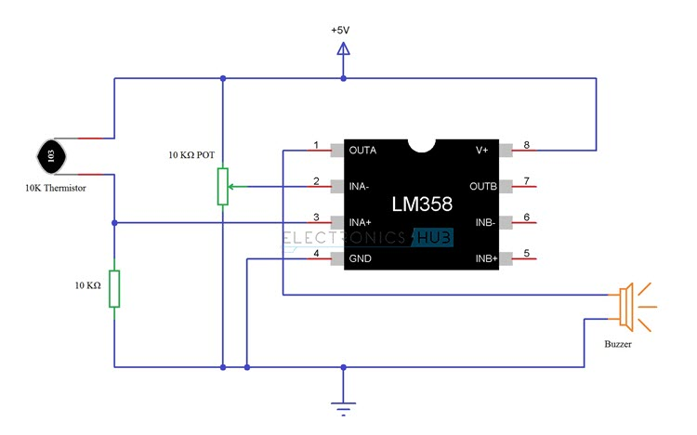

**Components Required**

* 1 x 10 K Thermistor
* 1 x LM358 Operational Amplifier (Op – Amp)
* 1 x 4.7 KΩ Resistor (1/4 Watt)
* 1 x 10 KΩ Potentiometer
* 1 x Small Buzzer (5V Buzzer)
* Connecting Wires
* Mini Breadboard
* 5V Power Supply

**Component Description**

***10K Thermistor***

Thermistors are Temperature Dependent Resistors i.e. the resistance of a Thermistor varies according to the ambient temperature. There are two types of Thermistors: PTC Thermistor and NTC Thermistor. PTC stands for Positive Temperature Coefficient and NTC stands for Negative Temperature Coefficient. In PTC Thermistor, the resistance is directly proportional to the temperature and in NTC Thermistor, the resistance is inversely proportional to the temperature.

In this project we have used a 10 KΩ Thermistor with NTC. At 250C, the resistance of the 10 KΩ Thermistor is 10 KΩ. The following image shows the 10K Thermistor used in this project.

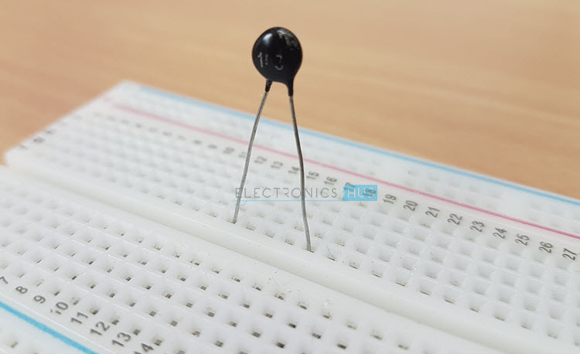

***LM358 Operational Amplifier***

LM358 is a Dual Operational Amplifier (Op – Amp) IC. All the functional modes of the typical operational amplifier can be implemented using LM358 IC. In this project though, we will be using the LM358 Operational Amplifier in the Comparator Mode where the input signals on inverting and non – inverting terminals are compared and corresponding output is produced.

**Circuit Design**

The design of the Fire Alarm Circuit with Siren Sound is very simple. First, connect the 10 KΩ Potentiometer to the inverting terminal of the LM358 Op – Amp. One end of the POT is connected to +5V, other end is connected to GND and the wiper terminal is connected to Pin 2 of Op – Amp.

We will now make a potential divider using 10 K Thermistor and 10 KΩ Resistor. The output of this potential divider i.e. the junction point is connected to the non – inverting input of the LM358 Operational Amplifier.

We have chosen a small, 5V buzzer in this project to make the alarm or siren sound. So, connect the output of the LM358 Op – amp to the 5V Buzzer directly.

Pins 8 and 4 of the LM358 IC i.e. V+ and GND are connected to +5V and GND respectively.

**Working of the Simple Fire Alarm Circuit**

We will now see the working of the simple Fire Alarm Circuit. First thing to know is that the main component in detecting the fire is the 10 K Thermistor. As we mentioned in the component description, the 10 K Thermistor used here is a NTC type Thermistor. If the temperature increases, the resistance of the Thermistor decreases.

In case of fire, the temperature increases. This increase in temperature will reduce the resistance of the 10 K Thermistor. As the resistance decreases, the output of the voltage divider will increase. Since the output of the voltage divider is given to the non – inverting input of the LM358 Op – Amp, its value will become more than that of the inverting input. As a result, the output of the Op – Amp becomes high and it activates the buzzer